Weekly memo#2

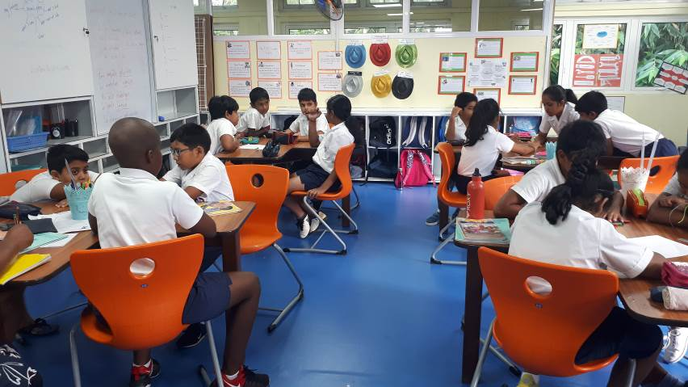This week has been a very exciting moment for the year 5A community. Learners were able to display their knowledge in a very efficient way as firstly to design questions under each key concept and these were eventually converted into phrases that in turn became the lines of inquiry. In all, learners were able to come up with 30 questions which were of interest to them. Since, only three questions will be focused on for this unit, the rest becomes a bank of questions from which learners can dig from to carry out their curiosity project. They will have to choose one question and they will look into that question and find explanations, which will help them answer, these and present their findings to the class. This is a very powerful opportunity given to them to teach each other while fine-tuning their presentation skills. Secondly, learners crafted activities that will help them collect information to answer their lines of inquiry whilst paying attention to using balanced sources of information that is primary sources as well as secondary sources. They were also informed of the purpose of keeping a bibliography as a way of abiding by academic honesty as well as protecting their work in case the information collected proved to be erroneous. The quality of the conversation was amazing hence showing learners making full use of their thinking skills and communication skills, as they were able to share their views in a very appropriate manner. Learners have nearly finished this part of their work and hence next week, learners will follow their plan to collect information and get the fieldtrips organized as they have also listed the experts they wanted to meet and now they need to contact these people and plan a visit. Learners also came up different formats to synthesize the information collected together with their proposals in terms of assessment, as they were able to come up with a list of items that needed to be present in their work as a way of showing their understanding.
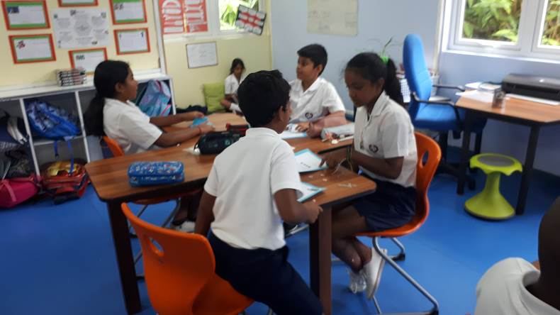
Last week, learners completed their reading assessment to identify their reading level and enable them to have a reading plan for the year. At the same time, they reread the story- An angel for Solomon Singer to become aware of the information they missed and misunderstandings they had about the story and which directly influenced on their synthesis. They discussed on their reading strategies and how improper application of the reading strategies led to them missing on important details. After a class reading of the book and discussion of the latter, learners were able to assess their first synthesis orally and were willing to have another try. Unfortunately, due to time constraint, they were not able to do so. Therefore they will complete it in the coming week together with trying out one on the own as a way to consolidate their understanding.

Learners were quite engaged last week with completing the revision of their first draft and attempting to the second one. They were able to give feedback to each other on the details they think need to be added to their story together with praising their peers on enjoyable aspects of their stories. Some learners have already started with their second draft and they will continue with this while they will be meeting individually with the teacher for a quick revision of their ideas. Learners will also come together to identify what to look for when they have to edit a piece of writing. It would be advisable not to go for too long a list of possible mistakes in order not to deter anyone from writing. Then, they will use the list they generated to edit each other’s text before they meet with the teacher personally for a final editing before they can publish their piece of writing.

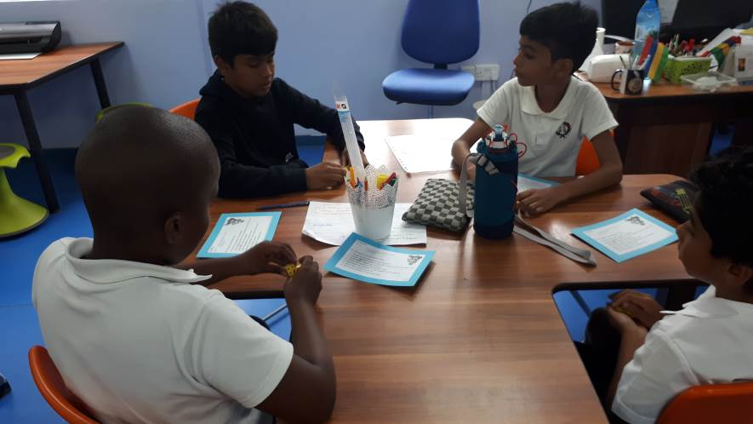Learners truly enjoyed the different maths stations as they could work independently in small groups. They could also help each other in revisiting and consolidating the number concepts. At the same time, a diagnostic test was carried out on fraction and it showed that all the students could identify simple fractions such as half, thirds and quarters. On the other hand many of them struggled to apply this sharing strategy to numbers and to find half or third or quarter of a given number. Equivalent fractions also proved to be difficult even if they could calculate the equivalence using an algorithm but the concept of equivalence was not that obvious. Hence, it has been decided to consolidate the basics of fractions to make sure the foundation is strong enough to build on the different concepts such as equivalence, whole and fraction together with carrying out operations on fractions.

