**U.O.I.**

**This week Learners drew a list of questions that they would like to inquire into besides the three teacher questions that usually guide the inquiry. These student questions were indeed very thoughtful and they displayed learners’ interest in the subject. I was personally very impressed by the yearning for knowledge coming from such young minds. After browsing books and unit resources, students discussed , shared and reported what they have discovered about the sources and forms of energy .The activity  met its objective in the sense that learners were able to differentiate between sources and forms of energy , something which is quite confusing to them.**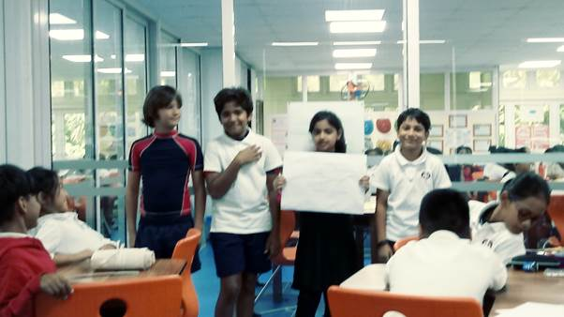

**Reading**

**An Angel for Solomon Singer by Cynthia Rylant** was completed and leaners were able to share at the end of the lesson from the notes taken .There were very good responses from the students in regards to their understanding of the theme. Moreover, the use of images and symbolism by the author to convey the feelings of friendliness , hopelessness  and loneliness  as well as those of hope was even mentioned .Furthermore, some students were even able to talk about how Solomon was missing the rural life where he lived and the friend he finally found at  a special café “where dreams come true.”

* **( Maths )  Fractions as a way of representing whole-part relationships was introduced. After the lesson, students understood  that fractions are parts of a whole and that  the total number of equal parts goes on the bottom of the fraction (the denominator) and the number of parts of the whole being given or kept goes on the top of the fraction (the numerator). Students were also able to demonstrate their understanding by identifying and writing fractions based on things they observe in everyday life. Ex : Learners were asked  to look around the room and identify more fractions they can find in the classroom such as  their textbook has 100 pages, with 10 pages in chapter one, to make 10/100, or that there are 15 pairs of scissors, and 7 of them are blue, to make 7/15.In a nutshell , most  students were able to**
  1. **Identify the numerator and denominator in a fraction.**

**2. Identify fractions by numerical value.**

**3. Identify fractions by picture**.

**Writing**

The strategy of *adding details to writing*. was demonstrated by the teacher to the whole class and one of the children’s drafts served as an example.. The revision technique namely 2 pluses and 3 wishes, which are two things they have really appreciated, and 3 things they wish the author would change to make their text more lively started very smoothly and they are still working on it.. They have started bringing in the changes by adding more details to render their writing more interesting in terms of its description and  character portrayal . It was a lesson which really captivated learners’ interest and they were amazed to discover how short and plain sentences could be improved  in length and substance and  convey visual  images through the use of appropriate details.